3. Data Flow Diagram (DFD)

3.1 Level 0 – Context Diagram
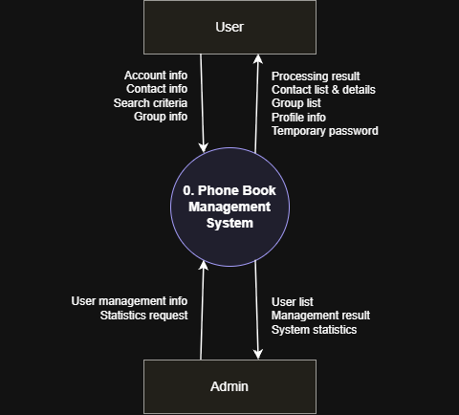
Figure 1. DFD Level 0 – Context diagram of the Phone Book Management System

3.2 Level 1 – Decomposition Diagram
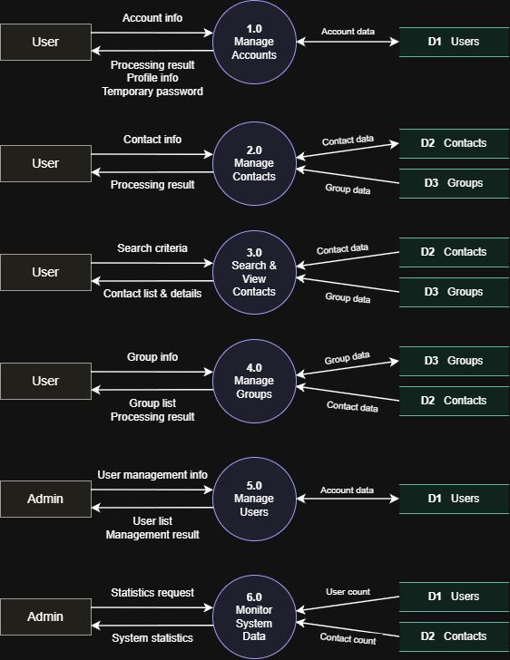
Figure 2. DFD Level 1 – Decomposition of the Phone Book Management System

